

Web Technologies I

# TERM PROJECT

**INSTRUCTOR: Javeria Aamir**

**CLASS:** Winter 2021 (CSD 1113_1)

Date: 02-04-2021

Prepared by:

Payal Desai C0793424

Srikanth Ajith Kumar Yarram C0793406

Yamini Rathod C0796390

**“Royal Travel Club”**

|  |
| --- |
| Section 1 – Planning Checklist |

* What is the Purpose of the Website?

This website would help the visitors to find the information regarding the fascinating places that visitors can visit. This website is not limited to a specific country. We have included best and renowned places around the world. Additionally we have included the known monuments so that visitors don’t miss anything when they visit to the certain place. We provide the travel package to our customers with discounts; we help them in arranging their accommodation, tickets, and suggestions to visit most popular places.

* Who is the Target Audience?

People around the world who are planning their trip may get the services from our website.

* How many pages will be included in your website?

There are total 8 pages in our website. The list is as mentioned below.

1. Home
2. Explore Places
3. Packages
4. Offers
5. Reviews
6. FAQ
7. About Us
8. Contact Us

* What graphics will you use on the website

We have used jpg, jpeg, png, gif graphics on our website.

* What colors will you use on the website

We have used a plethora of colors to make our website more attractive. Same is demonstrated in the upcoming pages.

* What font styles will you use within the website?

We have used all the CSS styles in the form of external CSS that was covered in the class; we have also explored some CSS by ourselves and included the same.

* What features will be displayed on the webpage?

Our webpage contains text, videos, images, forms, tables, links, navigation menu, and many more. We have included all kinds of context such as text, audio, video. Detailed feature is demonstrated in the upcoming pages.

|  |
| --- |
| Section 2 – Content Requirements |

Website sections:

* Home page - provide a brief overview of the business

We provide the travel package to our customers with discounts; we help them in arranging their accommodation, tickets, and suggestions to visit most popular places. We help our customers with arranging travel, renting hotels, renting transport and many more things with the attractive discounts. Home page would start with the navigation menu which will help our customers to redirect from one page to another page. The website is designed in the simple way considering all types of customers. It won’t be difficult to use, as the complexity of the website is very minimal. We have provided very abstract view of the information and all necessary information that customer is looking for is included.

* Contact
  + Location with a map

We have included the location map having the information about where we are mainly located. The same is demonstrated in the upcoming pages.

* + Hours of operation

We have included hours of operation information on our contact us page. The same is demonstrated in the upcoming pages.

* + Contact form

We have included contact us form on our contact us page. The same is demonstrated in the upcoming pages.

* About

Use these points to guide you on building the About page:

* + Why the visitors should bother reading your site

We offer wide range of offers to our customers. People around the world who are planning their travel may contact us to get help in travelling, booking transport, accommodations etc. We have provided detailed information about the same on our website. The same is demonstrated in the upcoming pages.

* + What problems you solve

We help our customers in their queries and we do offer the travel packages with the attracting discounts. People can reach us to get help in booking their travel with us.

* + How you can help them

We help our customers via phone, email service. Customers can also visit us as per their wish. We provide them travel package which would include everything in the minimal rate. Our services would make them travel without any trouble.

* Product or Service
  + Product(s) or service(s) description

The description of the service we provide has been mentioned in the website pages. The same is demonstrated in the upcoming pages.

* Maximum of 5 web pages.

There are total 8 pages in our website. The list is as mentioned below.

1. Home
2. Explore Places
3. Packages
4. Offers
5. Reviews
6. FAQ
7. About Us
8. Contact Us

* Must use only royalty free images for this project.

We have used royalty free images from the Google images.

* You can use Google Fonts.

We have implemented our own font style for our website.

* Use Semantic Wireframes to layout the features.

We have used Semantic Wireframes to layout our features.

* Applications for the product or service
  + Image Gallery (optional)

We have included Image Gallery on the home page. These images are taken from the attractive places.

|  |
| --- |
| Section 3 – Structure Requirements |

* Site Map (<https://draw.io>)

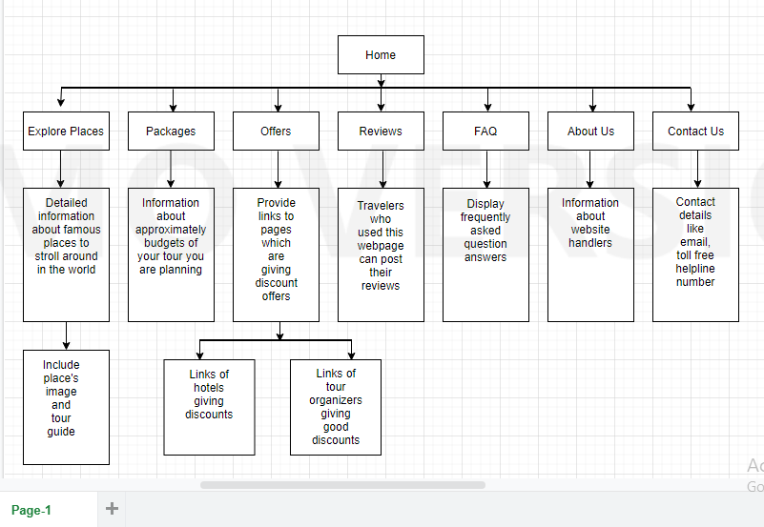

* Responsive design Wireframes (https://draw.io)

1. Home

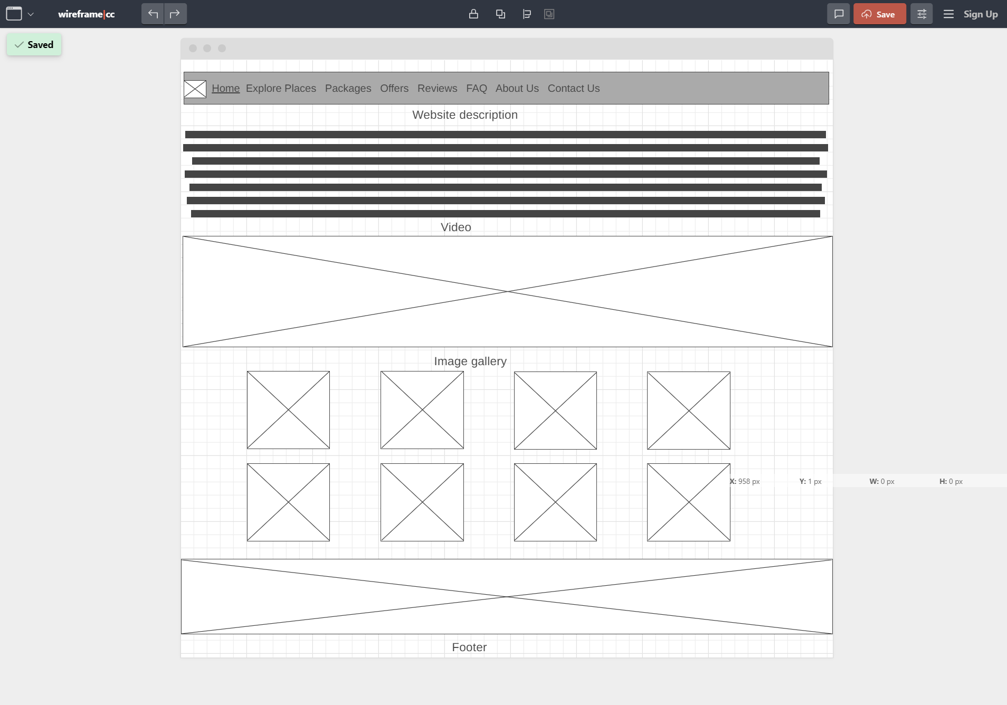

1. Explore Places

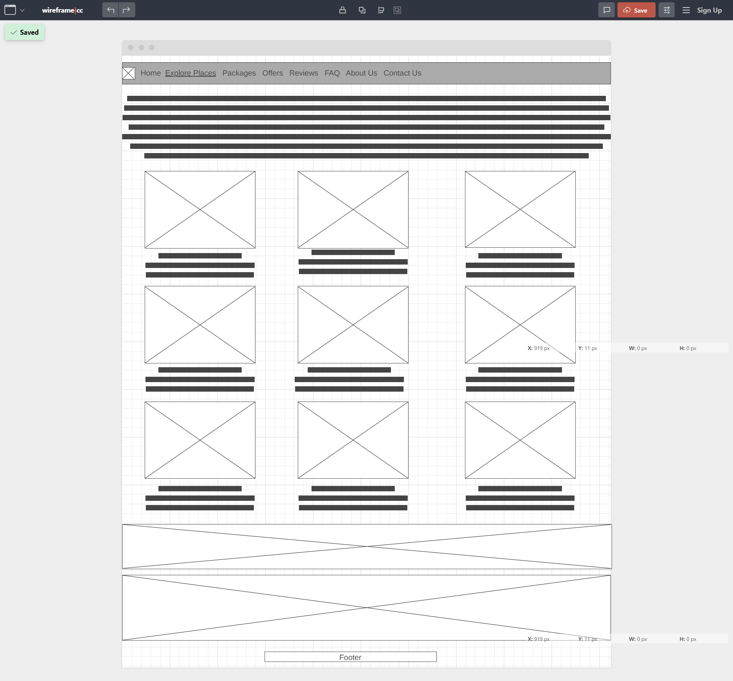

1. Packages

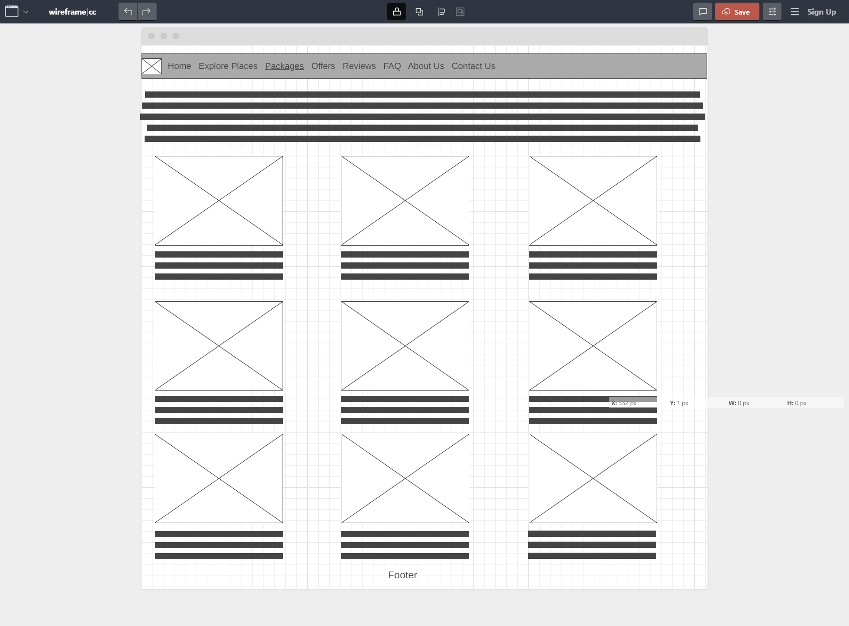

1. Offers

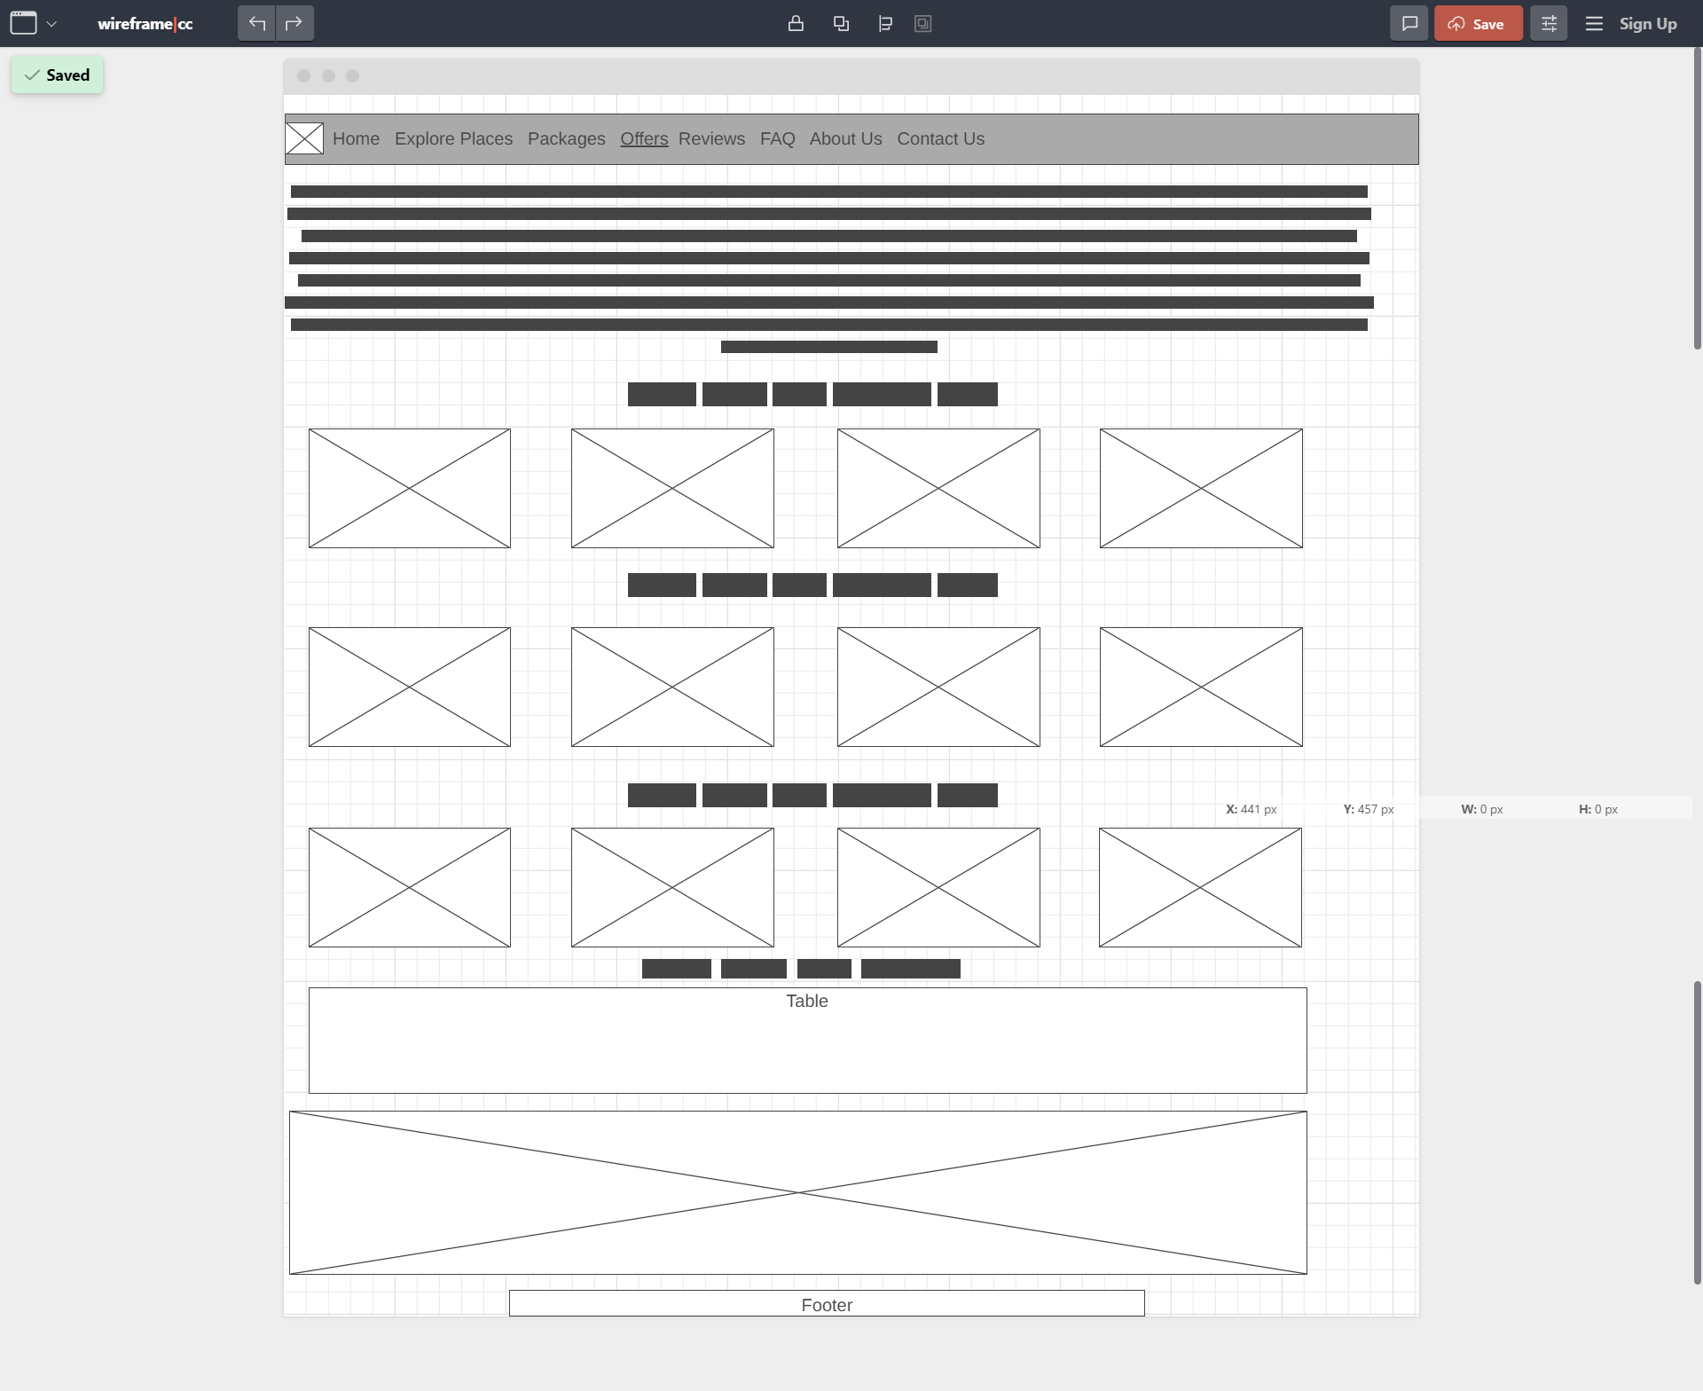

1. Reviews

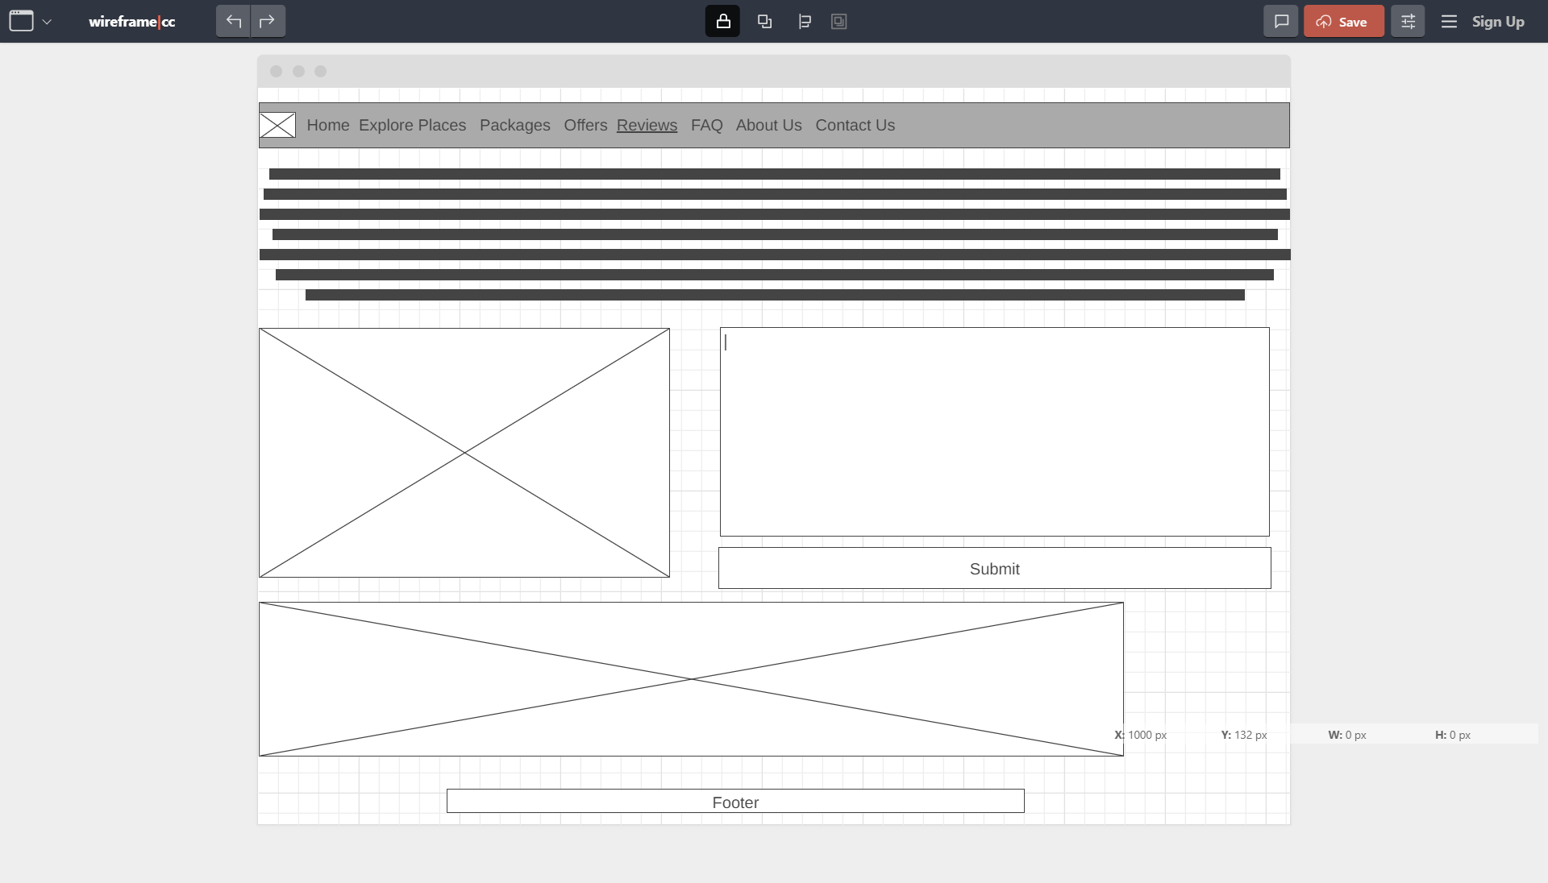

1. FAQ

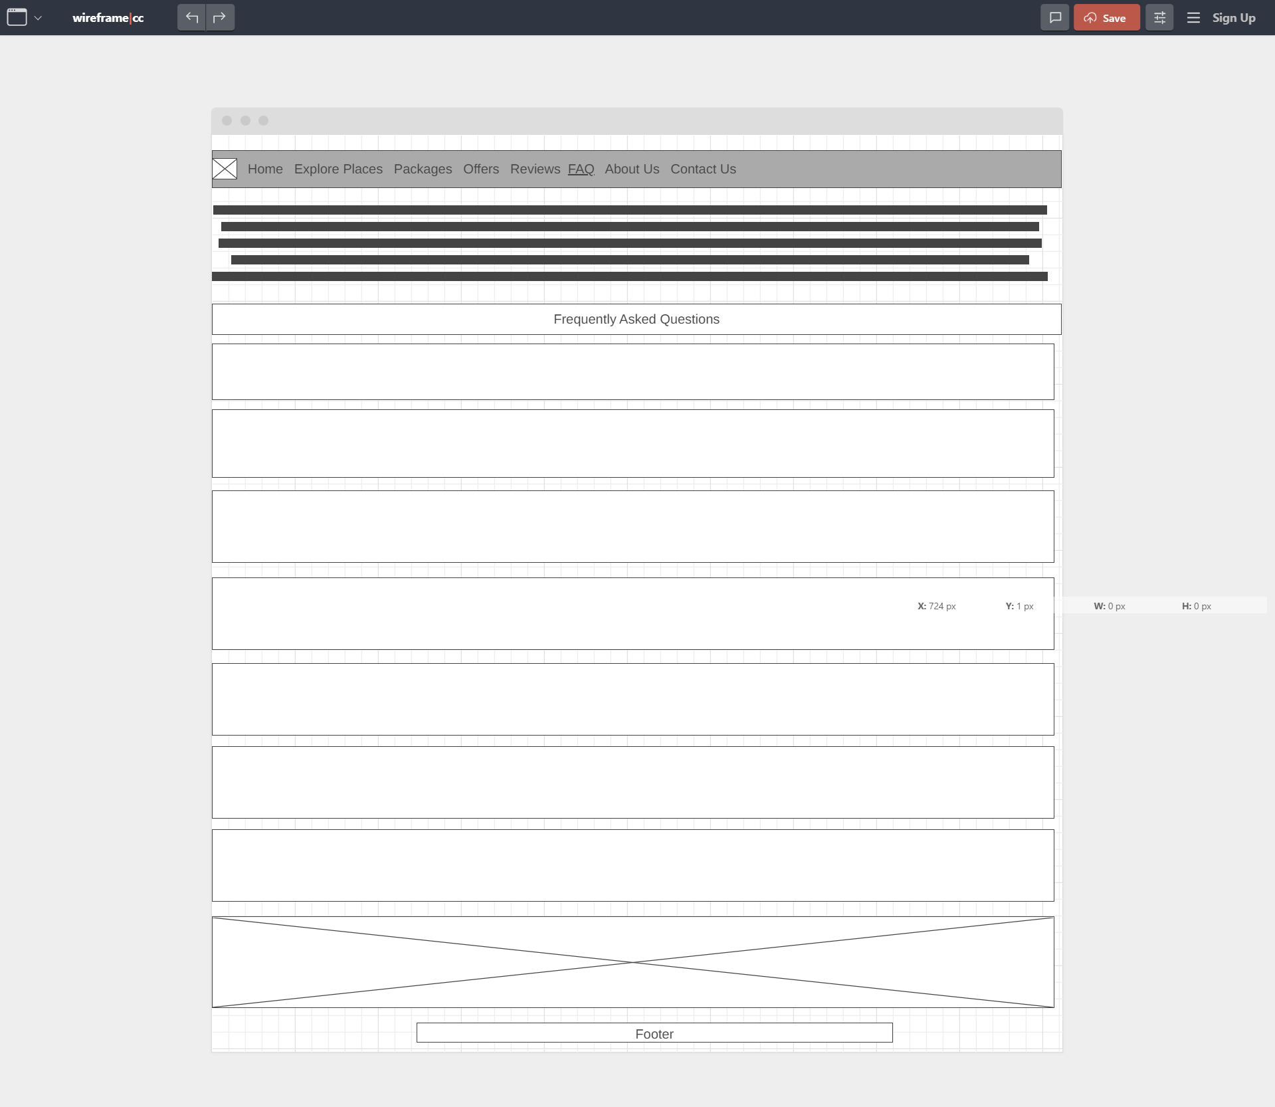

1. About Us

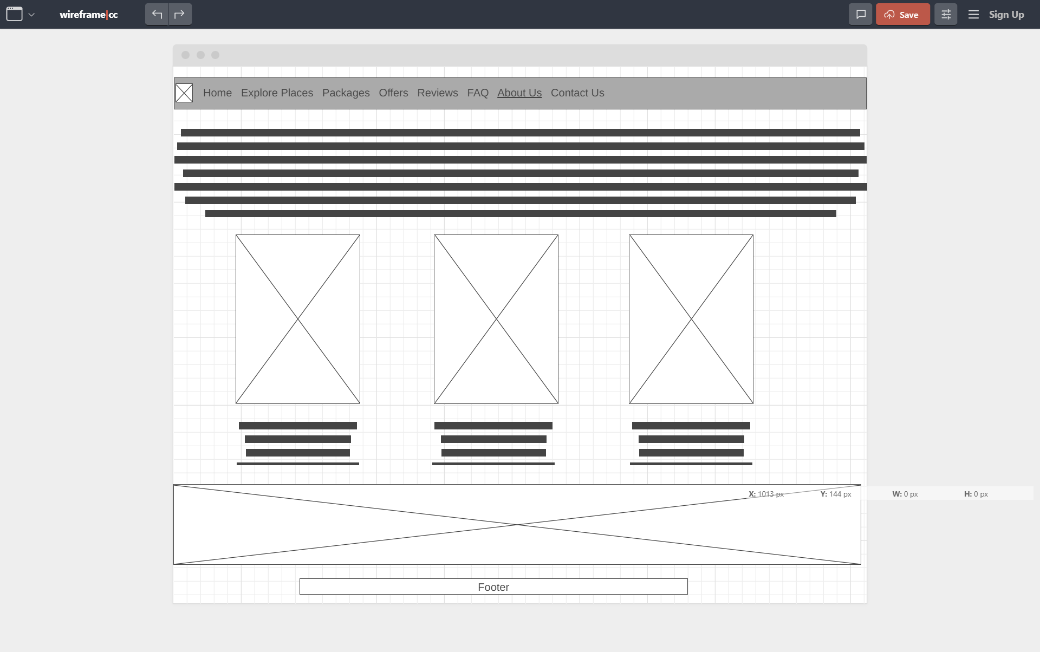

1. Contact Us



|  |
| --- |
| Section 4 – HTML Requirements |

Web pages must contain:

* HTML5 semantic elements

We have used HTML 5 semantic elements in our website such as aside, article, div, span, section and so on.

* Meta tags

We have included most important Meta tags such as charset="utf-8", name="viewport" content="width=device-width, initial-scale=1" in all WebPages

.

* Links

We have included all types of hyperlinks, including text links, video links and image links in our websites.

* Images

We have included images of various types such as jpeg, jpg, tiff, png in all WebPages.

* Block and Inline content

We have implemented block and inline content in many of the WebPages of our website.

* Forms with basic validation

We have implemented form in our contact us web page, we have included basic validation inside it.

* Tables

We have included comparison table inside our offers page, demonstrating the value of price, normal price, price with taxes and discount price etc.

* Headings

We have included heading in the various places of our webpage whenever required.

* Paragraphs

We have included paragraphs in most of the WebPages whenever we were required to demonstrate the contents.

* Lists

We have implemented lists in the menu bar of the website.

|  |
| --- |
| Section 5 – CSS Requirements |

* Fluid layout

We have implemented CSS in the form of fluid layout, using property called device with the value fluid.

* Media queries

We have implemented media queries in the website. Same would be demonstrated in upcoming pages.

* Flexible images

We have implemented flexible images, for example by keeping certain image width to the percentage level hence it would not be getting enlarge or shrink as per the device. It would be in the standard format.

* Box model

We have created html box model in our CSS style.

* Text and font styling

We have implemented various text styles and font styles. It is different for heading, paragraphs, tag lines, links etc to make to more readable.

* Forms styling

We have implemented CSS in forms by including proper color, text size, length in the form fields.